The Case of
The Altered Document

using chromatography to solve a crime

Paul Redmond
Teacher’s page:
Curriculum: Paper Chromatography
Write out an IOU note for each lab group

“I Mr Leddy owe Mr Morrison 5000 euro and will pay it back by 1st Sept 2009”

NOW:
- Cross out the 5 and change it to a 3
- Cross out the Sept and change it to Dec

(All markers used should be water based)
Equipment:
Markers
Filter Paper
Distilled water
Title: An Altered Document
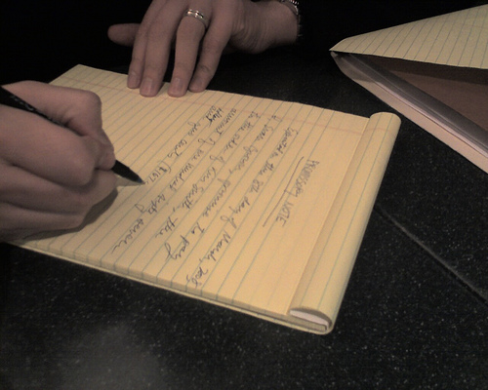 http://farm3.static.flickr.com
The Case:
Mr Morrisson lent some money to Mr Leddy a friend of his. Mr Morrisson wrote two notes. A copy for each of them explaining how much was lent, when it was lent and when it had to be repaid by.
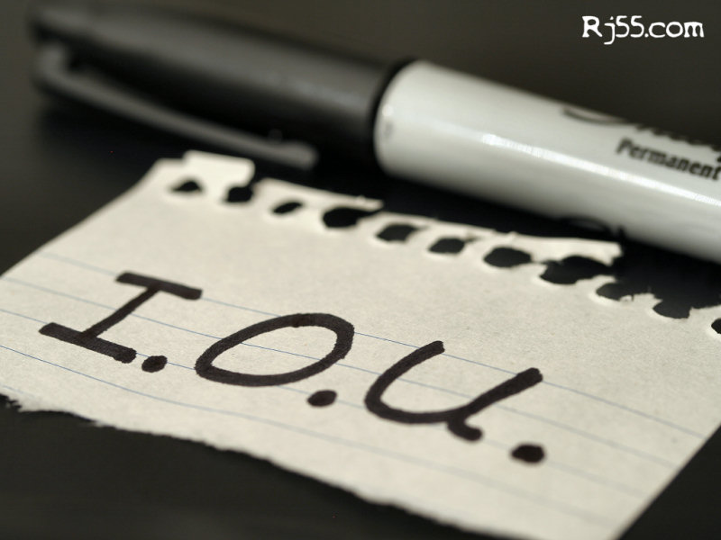 http://rj55.com
Mr Morrison lost his note and contacted Mr Leddy and asked him could he have a copy of his note. Mr Morrison claimed that the amount of money lent and the repayment deadline had been altered using a marker. He claims Mr Leddy did this after he received the note. Mr Leddy adamantly denies this. He Claims Mr Morrison made the changes after the changed the conditions during the loan agreement.
Mr Morrison has laughed at this suggestion
 (www.everythingcounts.com)
The Evidence:
You as a CSI have been collecting evidence. You have:
- Mr Leddy’s copy of the note
- 4 Markers that have been found in Mr Leddy’s house that may have been used to alter the IOU note.
Task 1:

Your job is to determine if the note was altered by Mr Morrison before giving it to Mr Leddy or was it altered by Mr Leddy (without mutual agreement) using one of his markers?

Method:
- Cut out the piece of the altered paper
- Dissolve the ink from the paper in a small amount of distilled water
- Place a dot of the dissolved ink on filter paper and run the chromatogram.
- Run a chromatogram for each of the evidence markers
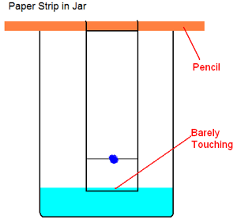
http://www.sciencebuddies.org

If you conclude that one of the markers was used to alter the note tick the marker in the box you think it is
 | Marker 1 | Marker 2 | Marker 3 | Marker 4
Altered paper ink

Questions:
In your opinion was one of Mr Leddy’s markers used to alter the note

